For this project my goals are as listed:
- Create a Virtual Machine that will host the windows 10 workstation.
- Set up the virtual machine.
- Disable Windows game recording in the local group policy.
I’ll be documenting all of it, including any issues I may come to find.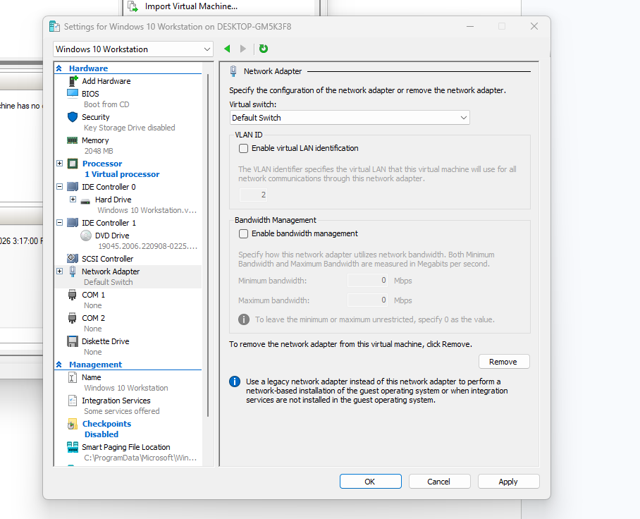
This is my current setup for the virtual machine that’ll be running the Windows Workstation.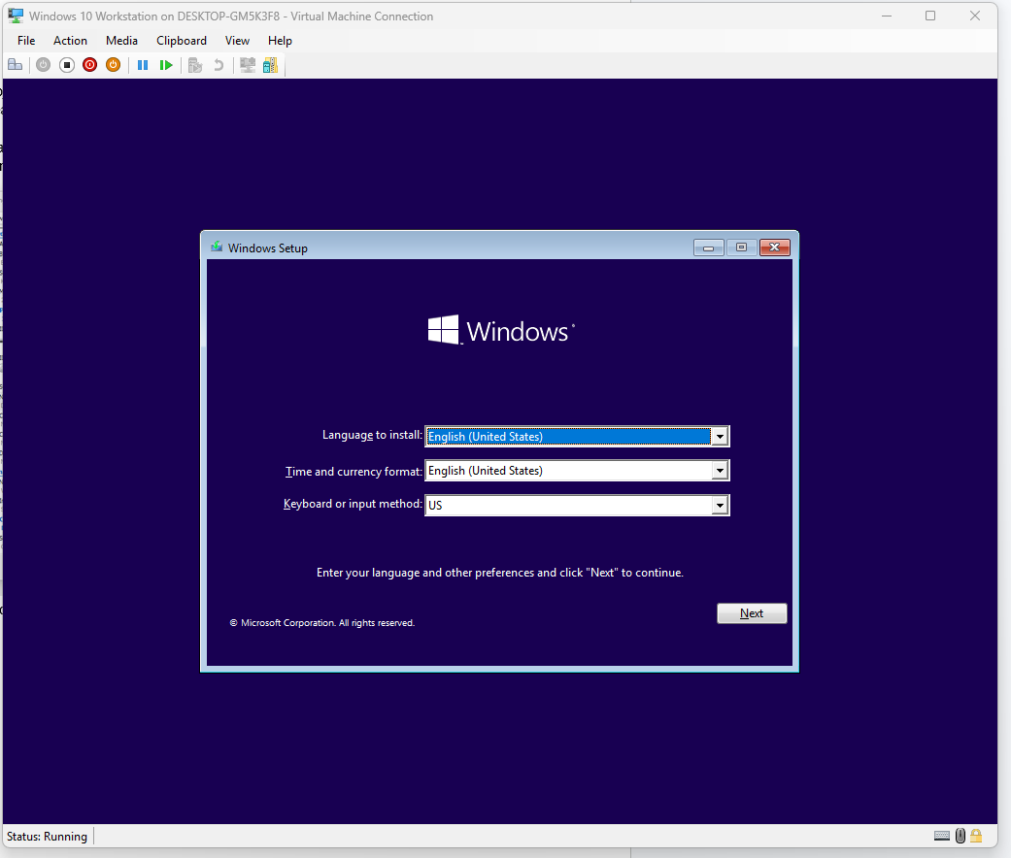
I got it to bootup, now I’ll begin installation of Windows.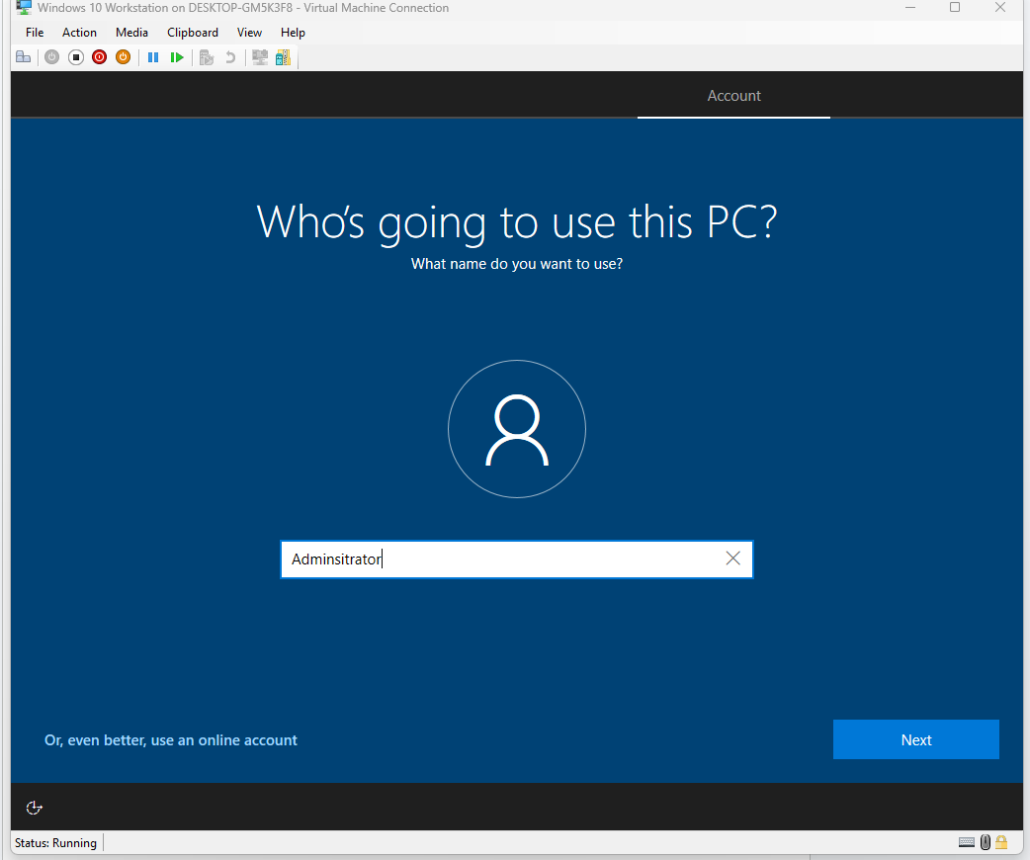
I created an account via a domain rather than using my own personal account for this. (I just realized my spelling mistake, oops.)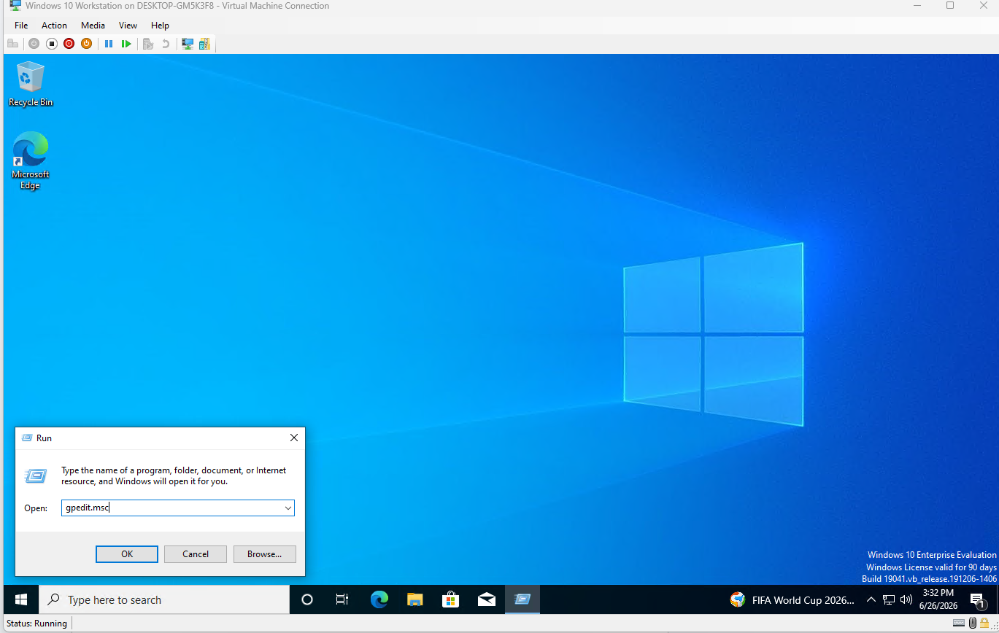
With Windows done installing, I can access the Local Group Policy using the “gpedit.msc” command.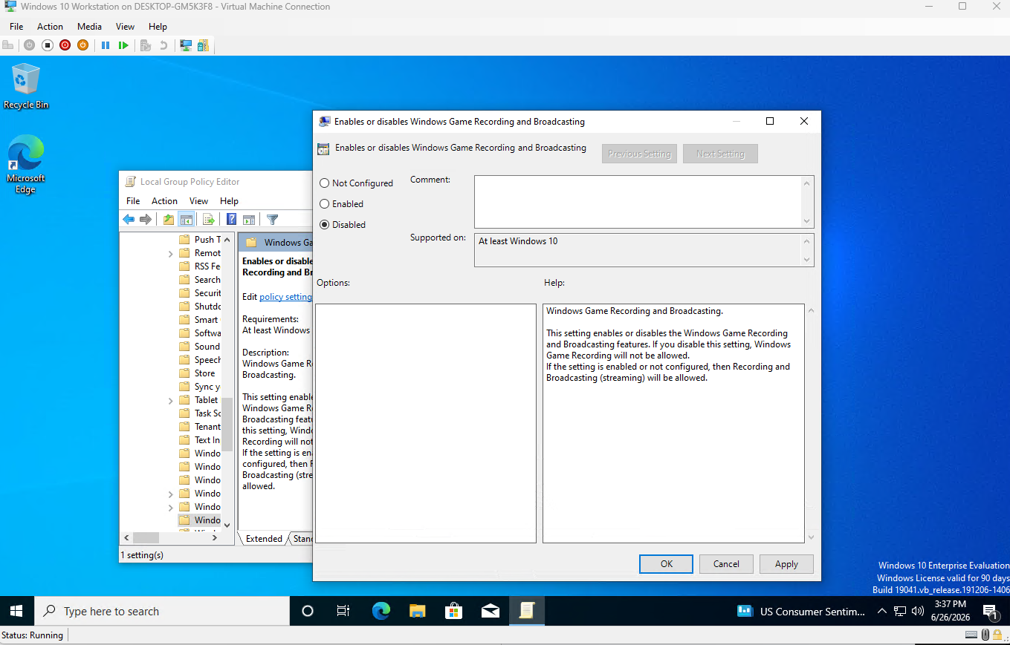
I found the policy under Computer config > Administrative templates > Windows components > Windows game recording.

What this project has taught me is to be familiar with searching deeper for the folder and to take my time, because it took me a while to find it in the first place. It has also taught me patience, and to have the desire to keep searching even if it may seem tedious at first. Overall it has made me a bit more comfortable with searching things via Group Policy editor, and changing policies altogether.

